Garrett Whiteker
February 1, 2026
Assignment 4
Advanced Programming Languages
University of the Cumberlands
Dr. Thom

Python code screenshots
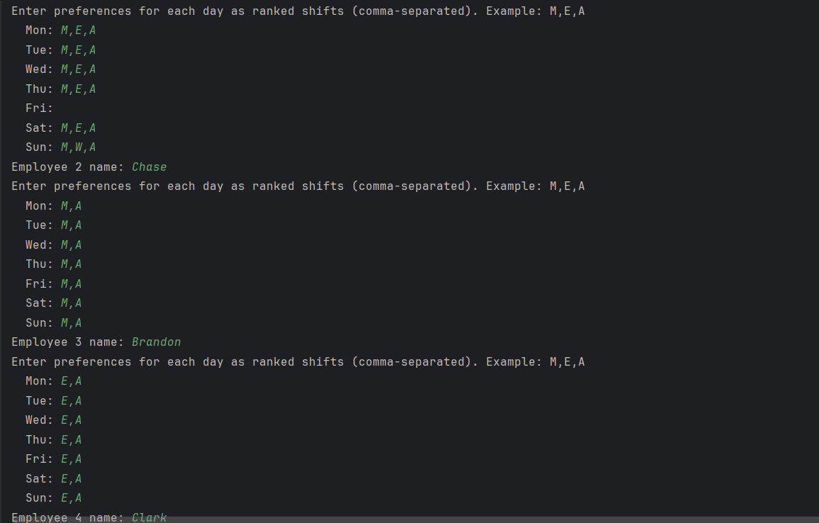
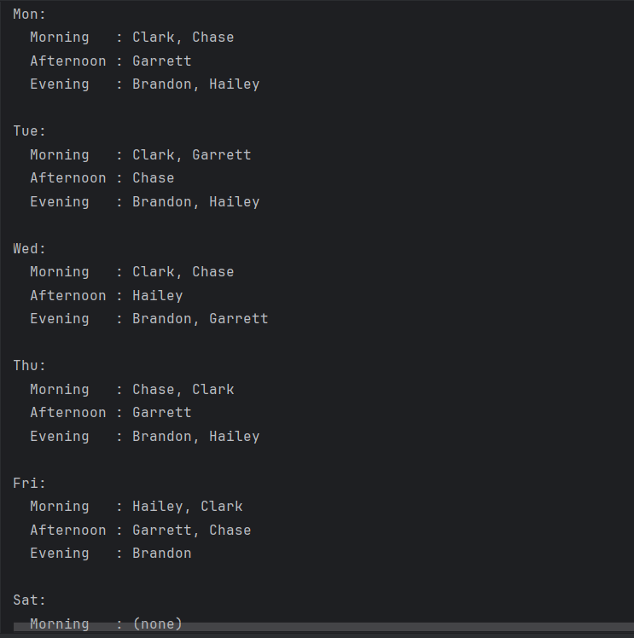
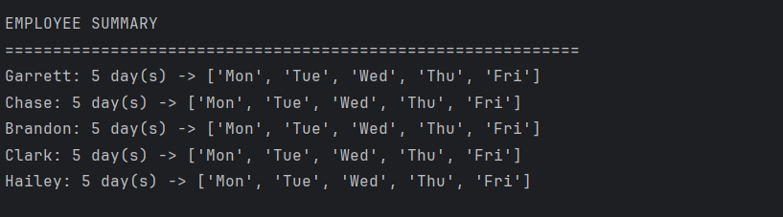

C++ Screenshots and code link
https://www.tutorialspoint.com/code/dGerK6um
